Lab report :3

Exercise 1:

1. Go to the root directory and see the current permission of /home

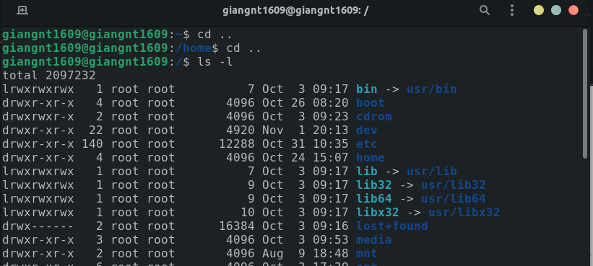we could see the permission is rwx r-x r-x. Now, using chmod with sudo to change the permission of home directory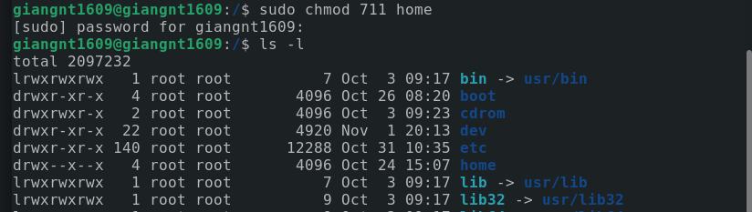. After that, list all file to see the new permission, we get rwx –x--x.

2. By default, when we create new files, they are given rw-rw-r– permissions. The r, w, and x signify the read, write, and execute permissions, respectively.

For example, create a file vanban.txt in ~/ directory

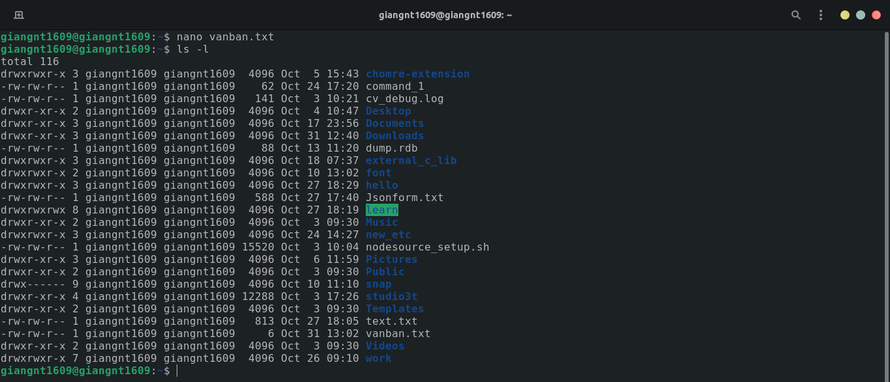we could see the default permission is rw-rw-r-- while using ls -l to see all files and directories in ~/

3. Move to root directory and list everything

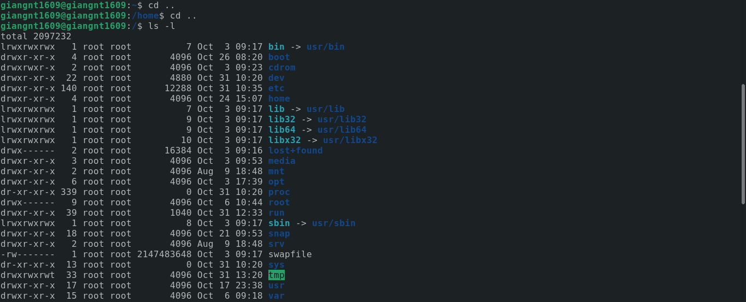

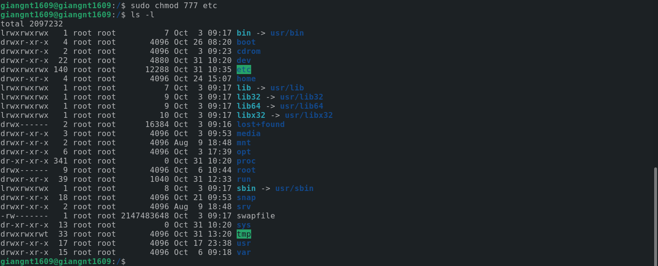we see the permission of etc is rwx r-x r-x, to change the permission using chmod command by administrator’s permisson with sudo. Set all permission read, write, execute for all and we have the result.

4.

See that the permissions of .bashrc is rw- r-- r--

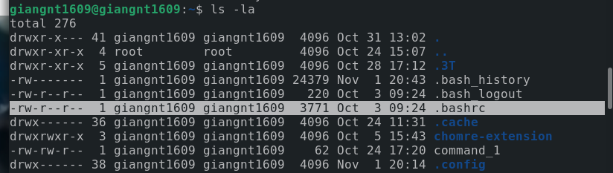 using chmod to change the permissions

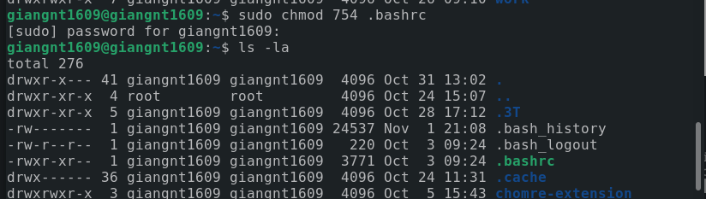5.

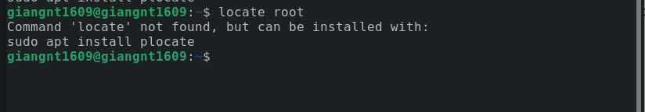The system can’t find the command locate.

6.

We can use a symbol link because the symbol link will create with all permission of diretory.

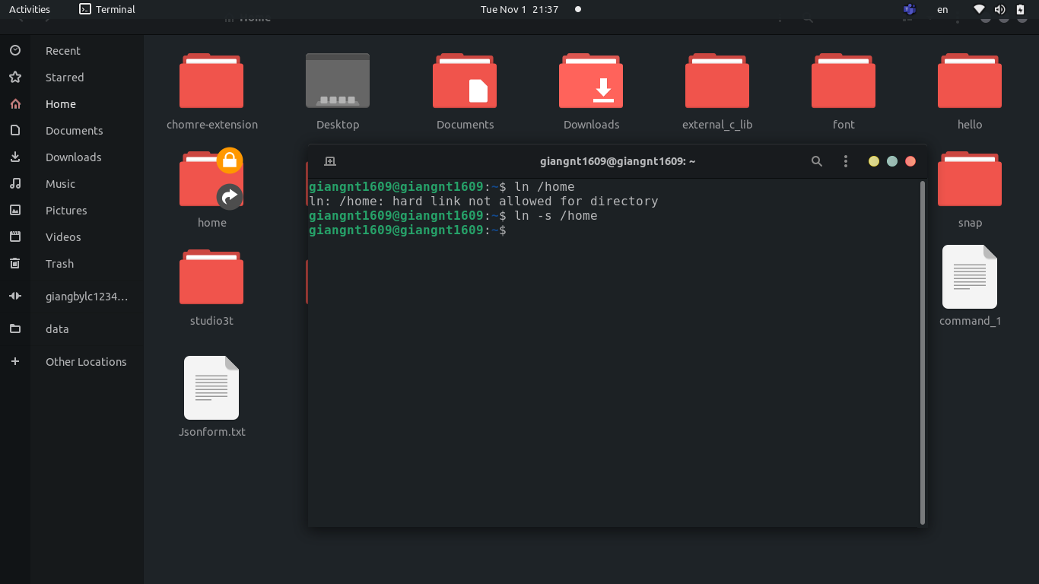

Exercise 2:

1. Create the file test.txt and try use 3 ways:

+ Using chmod commands:

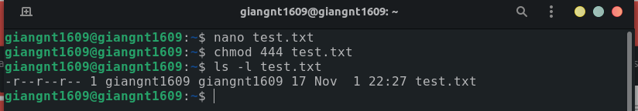

+ Using bitmask:

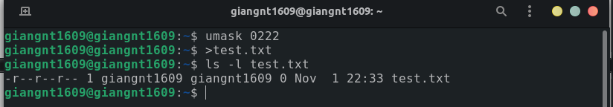+ Using GUI: right-click on the file and choose property after that we can set the permissions for the file.

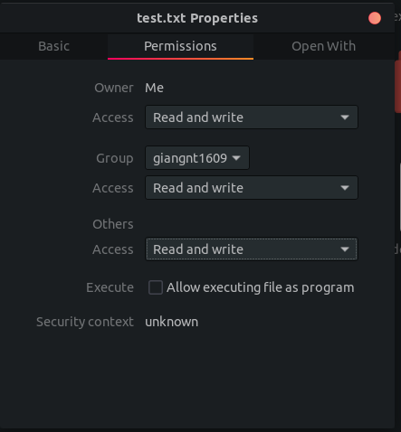

2. Copy /bin/sh to /home and add permission +s to the file sh.

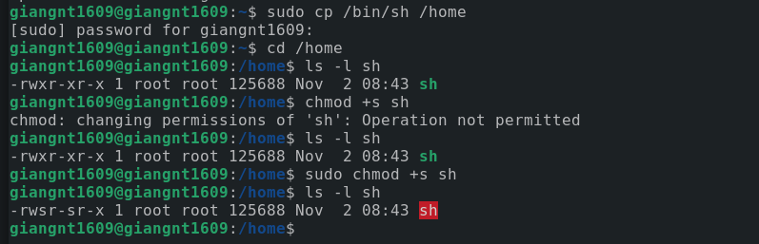

Change to other acount and access to first account home directory.

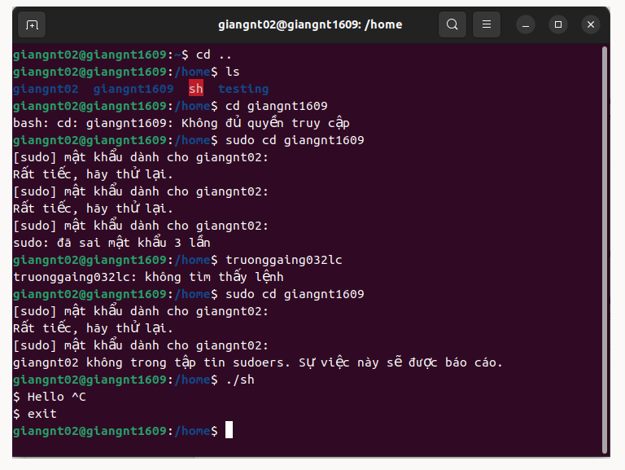The access was denied because the permission was missing.

4. remove the sh file: in home directory using command rm sh



5.

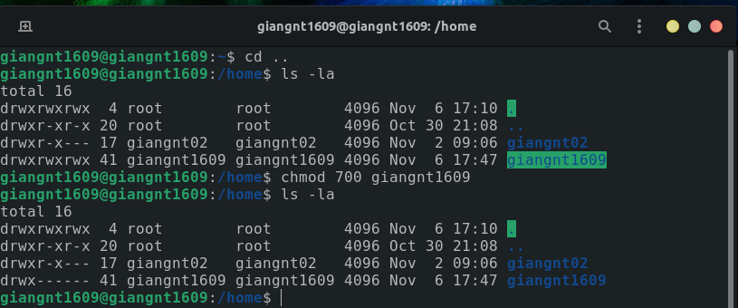set the permission of home directory using chmod 700 then the account is private. When using the other account to access, the action will be denied like picture in part 2.

After that using chmod 755 cho reset the origin permission.

6.

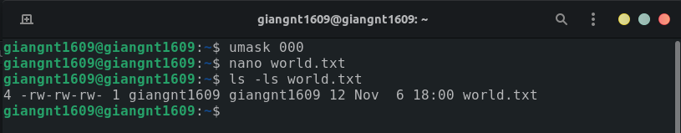

the file permission of the file after running commands will be set to -rw -rw -rw

because the permission default for a file is 666. The permission set for the file when using umask 000 is 666 - 000 = 666.

7

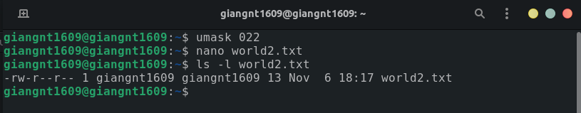

the file permission of the file after running commands will be set to 644

because the permission default for a file is 666. The permission set for the file when using umask 022 is 666 - 022 = 644.

8.

create a hello.txt file in home directory then change to giangnt02 user by command su – giangnt02.

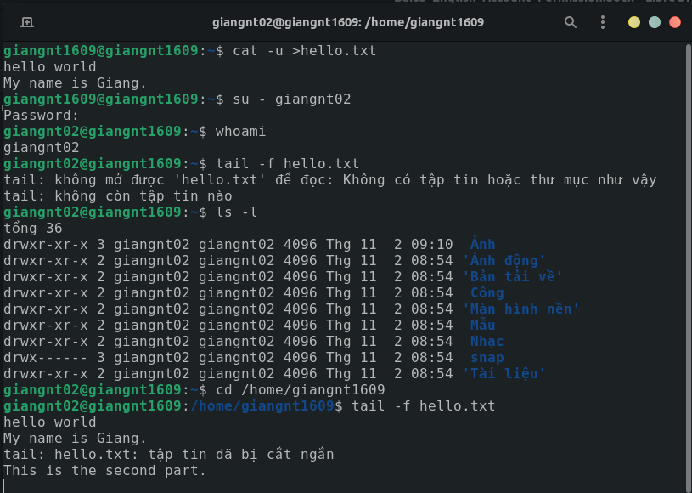

Change the directory to the home of the first account then running the command tail -f hello.txt

Switch back to the first account and add some line

the content of file in the the second view will be changed by adding more line which the first user input

Exercise 3:

1. create 4 group:

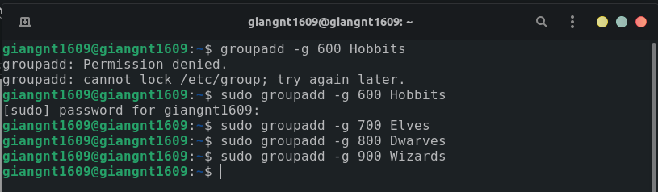2 create 5 user

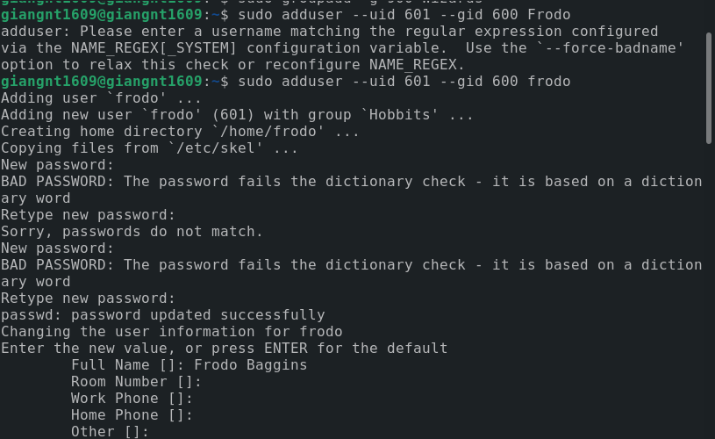

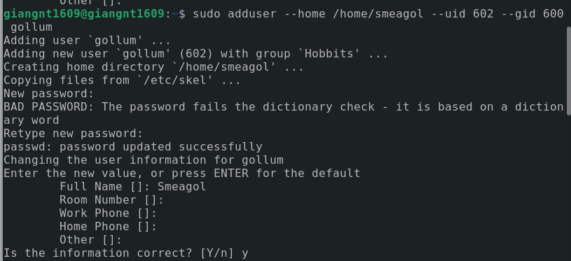

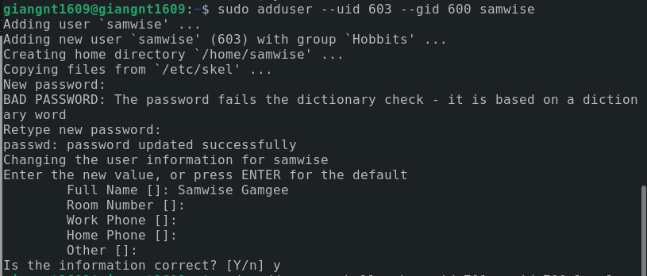

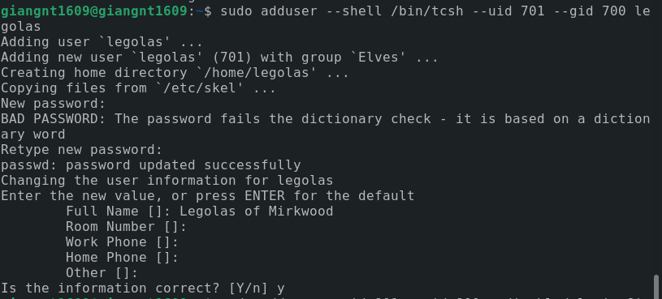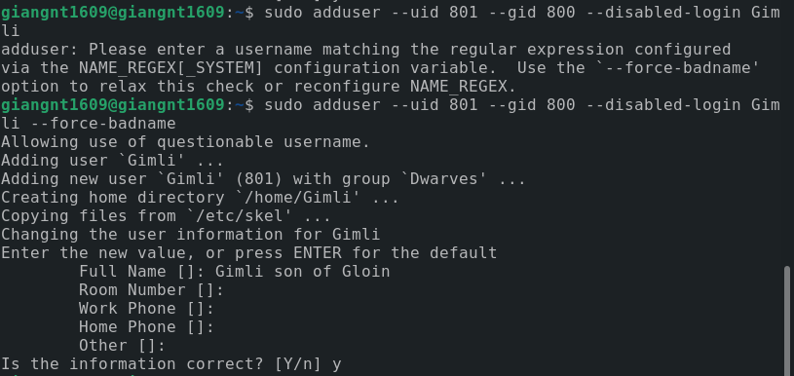

3.

using “sudo passwd frodo” to change the password of user prodo and the expired the password to force the password must be change in the next login.

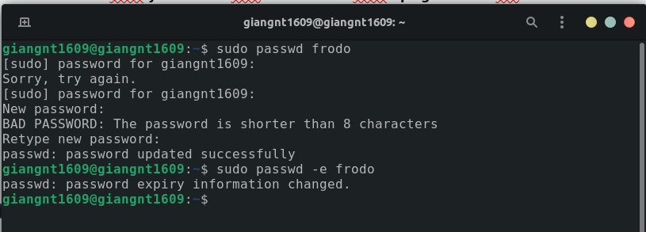

4. use id commands to check group and use sudo usermode -g to set the primary group.

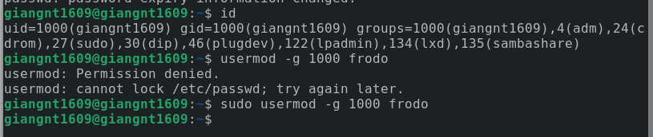

5.

use id commands to check and use sudo usermode -l to change the username of Legolas.

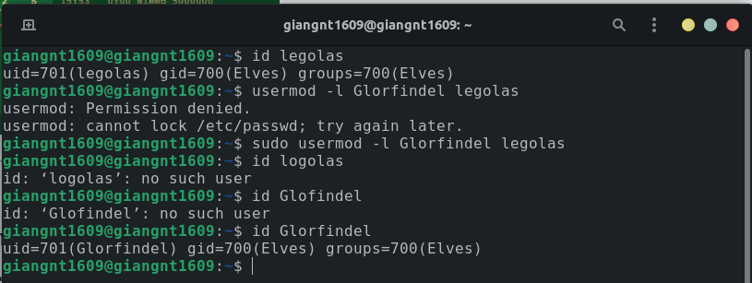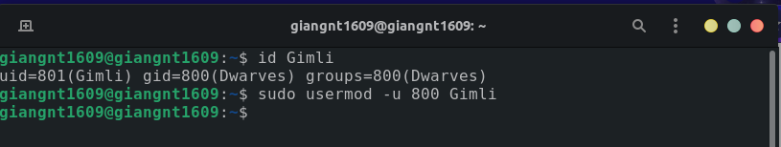6.

use id commands to check and use sudo usermode -u to change the UID.

7.

use sudo usermode -L to lock the user .

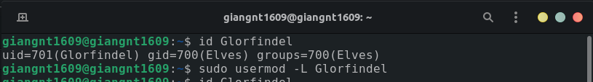8.

use sudo userdel -r to remove user including home directory.

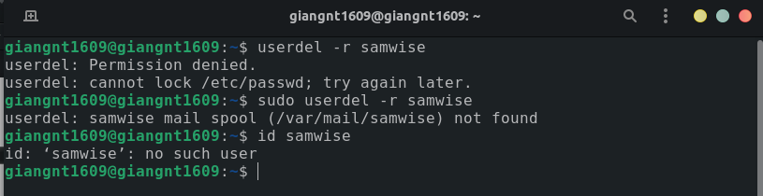9.

using sudo nano /etc/motd to change the content of the file and save the file.